**INTERMITTENT DEMAND FORECASTING  
FOR MEDICAL** SUPPLY CHAIN MANAGEMENT: REVIEW

Yu Jin  Department of CIISE Concordia University Email:yu.jin@mail.concordia.ca

ABSTRACT

Accurate demand forecasting is always critical to supply chain management. However, many uncertain factors in the market make this issue a huge challenge. Especially during the current COVID-19 outbreak, the shortage of certain types of medical consumables has become a global problem. **The intermittent demand** **forecast o**f medical consumables with a short life cycle brings some new challenges, such as the demand occurring randomly in many time periods with zero demand. After review, **a dynamic neural network model** is found as the main forecasting models. Experimental results [1] show that the proposed forecasting framework is superior to other intermittent demand models.

**Keywords.** Intermittent demand; demand forecasting; supply chain management; medical supply chain management.

**1.INTRODUCTION**

**1.1 Definition of Intermittent Demand Forecasting**

Intermittent demand or ID (also known as sporadic demand) comes about when a product experiences several periods of zero demand. Often in these situations, when demand occurs it is small, and sometimes highly variable in size. [4]

The main characteristics of the intermittent demand forecast of medical consumables:

* Large proportion of zero daily demands,
* A large number of different products
* Short life cycle
* Short sell seasons
* Long replenishment lead time

Therefore, the intermittent and slow-moving nature of demand makes forecasting particularly difficult.

* 1. **Forecasting difficulties**

The many zero values in ID time-series render usual forecasting methods difficult to apply. For example, single exponential smoothing (SES), proposed in 1956, was the first forecasting method to be applied to intermittent demand. Unfortunately, SES is known to perform poorly in forecasting for ID, since there is an upward bias in the forecast in the period directly after a non-zero demand. [4]

This paper will do literature review on new methods that can forecast the intermittent demand with short life cycle, which may help supply chain decisions during the epidemic. The main characteristics of this typical medical consumables are short lifecycle, large proportion of zero daily demands, various product styles and long replenishment lead time. Since the demand for medical consumables is usually erratic, we introduce the techniques of dropping outliers, seasonal adjustment and aggregation to preprocess historical data. In addition, a new forecast accuracy measurement is proposed specifically for the zero demand records and a dynamic neural network is designed to handle the erratic and unstable demand data.[1]

* 1. **Classification methodology**

Papers are obtained through www.sciencedirect.com with the keyword "Demand forecasting " and "Intermittent demand forecasting", “Supply Chain management” and “medical supply chain management”. Paper in demand forecasting is classified into two types: Demand forecasting (DF) and Intermittent Demand forecasting (IDF).

DF: Classification papers in “Demand forecasting “&& “Medical supply chain management”: 11 papers

IDF: Classification papers in “Intermittent Demand forecasting “&& “Medical supply chain management”: 17 papers

Date range: 2017 - 2020

With/Without PDF file: With PDF

The remainder of this study is structured as follows.

Section 2: Literature review in data aggregation

Section 3: Literature review in demand forecasting

Section 4. Literature review in performance assessment

Section 5: Conclusion and future research directions

* 1. **Literature review: Our findings**
* Demand forecasting - minimum description length neural network (MDL-NN), is selected for Intermittent Demand Forecasting.
* Performance assessment - Smoothed mean square error (MSE) has been selected to estimate the variance of demand forecast.

Model election is very important to forecast the demand for such short life cycle products because of the considerable irregularity data. In our research, a new forecasting accuracy measure for the model to deal with zero demand, and introduce a dynamic neural network, minimum description length neural network (MDL-NN), as the core part of the forecasting model. MDL was originally used to minimize the sum of length, which includes an effective description of the model and length, and an effective description of the data when coding with the model in time series forecasting, the description length of a model is the sum of the model description length and the model prediction error. MDL-NN searches for the optimal model size (i.e. the number of neurons in neural network), and avoids overfitting or underfitting by minimizing the model’s description length and its performance. [1]

2.**LITERATURE REVIEW**

* 1. **Demand classification**

Eaves and Kingsman (2004) proposed loose classification of demands as the function of demand and quantity variations (Table 1). (Syntetos, Boylan, Croston, 2004) quantified this conceptual classification and proposed experimental cutoff values for coefficient of variation (*CV2*=0.49) as representative of quantity variation and average demand interval (*ADI*=1.32*)* as representative of demand variations. [14]

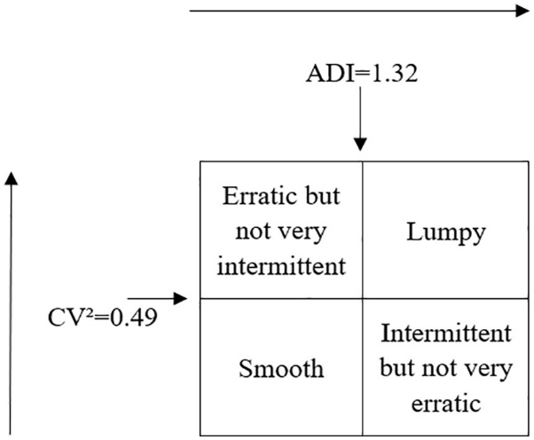

Figure1: Classification of demand patterns [1]

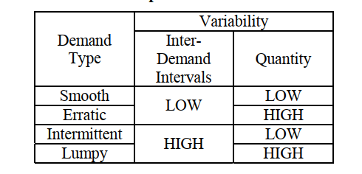

**Table 1:** Four considered demand type and variability representation [14]

In the figures below, simulated intermittent demand from each demand category (intermittent, lumpy, erratic, and smooth) are demonstrated (figures 1, 2, 3, 4).

Figure 1: **Figure 2**: An example of smooth data[9]

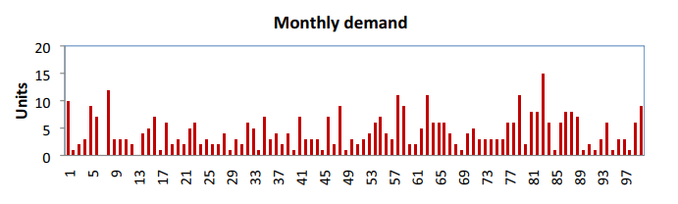 Figure **Figure 3**: An example of erratic data. [9] ---demand for medical epidemic

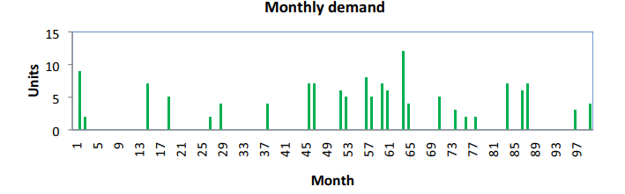 **Figure 4**: An example of intermittent data.[9]

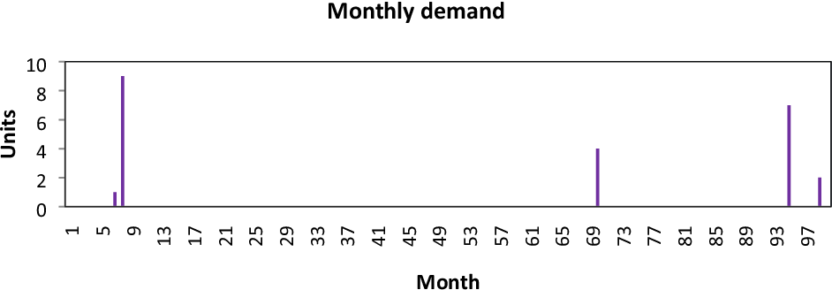**Figure 5**: An example of lumpy data [9]

* 1. **Intermittent Demand Time-series Forecasting Methods**

|  |  |  |  |
| --- | --- | --- | --- |
| **Methods** | **Croston’s Method** | **SBA** | **SES** |
| [6]-2020 | X  Smooth demand | X  erratic,  lumpy, intermittent | No |
| [1]-2020 | X |  | X-NO |
| [7]-2013 | X | X | X |
| [8]-2014 | X | X | X |

**Table 2**. Literature review: Previous Intermittent Demand Forecasting Methods

Intermittent demand is characterized by several periods of zero demand interspersed by occasional non-zero demands. It follows that conventional time-series methods such as moving average and **simple exponential smoothing (SES**) would over-estimate the mean demand if applied immediately after a non-zero demand incident (Croston, 1972). To resolve this issue, Croston (1972) separated the demand series into two components – i.e., demand sizes and inter demand intervals – and used SES for each of them; the per-period forecast was derived from the ratio of the smoothed demand size to the inter-demand interval. Essentially, Croston (1972) captures the compound nature of intermittent demand distribution. This method, however, assumes a stationary mean model (i.e., without trend and seasonality; for extended models, see Altay, Rudisill, & Litteral, 2008; Bermúdez, Segura, & Vercher, 2006).

Syntetos et al. (2005) proposed a demand classification scheme (hereafter SBC) with two dimensions: the average inter-demand interval (*p*) and the squared coefficient of variation of the demand sizes (*CV*2). This outcome was derived from the comparisons of the theoretical mean square errors (MSEs) of three forecasting methods: (1) Croston; (2) Syntetos and Boylan Approximation (SBA) – a bias-adjustedversion of Croston**;** and (3) SES. It has been shown that SBA was optimal for *p* > 1.32 and/or *CV*2 > 0.49; otherwise, Croston was dominant. Accordingly, the classification scheme consisted of four distinct demand categories – erratic, lumpy, smooth, and intermittent – and their recommended forecasting methods – Croston for smooth demand and SBA for the others.Kostenko and Hyndman (2006) elaborated the comparison between SBA and Croston in Syntetos et al. (2005) and suggested another scheme (hereafter KH): using SBA for *CV*2 > 2-(3/2)*p* and Croston otherwise. Based on this boundary, there were two demand categories: smooth (when Croston was better) and lumpy (when SBA was better). [6]

Despite their advantages and disadvantages, among these above schemes, SBC is widely adopted in the literature. Hence, this study follows this scheme due to its parsimony and comparability to previous work. In particular, we deploy three parametric forecasting methods – **Croston, SBA, and SES –** in our analysis. Another reason for selecting these methods is that their effectiveness in inventory control has been proven in the literature when comparing with non-parametric approaches such as bootstrapping (Syntetos, Zied Babai, & Gardner, 2015).[6]

Paper[6]: The comparisons of the theoretical mean square errors (MSEs) of three forecasting methods are listed : (1) Croston; (2) Syntetos and Boylan Approximation (SBA) – a bias-adjusted version of Croston; and (3) SES., Croston was dominant. Accordingly, the classification scheme consisted of four distinct demand categories – erratic, lumpy, smooth, and intermittent. The recommendation of [6] is Croston for smooth demand and SBA for the others (lump, erratic, intermittent)

Paper [4]: listed the methods most used in industry today.

Paper [1]: Croston Single Exponential Smoothing (SES) did not perform well for intermittent demand. Their experiments have shown that Croston’s method outperforms traditional forecasting methods for intermittent demand.

Paper [8]: the SBA method was more accurate than SES and the original Croston

**2.3 Data Aggregation**

Extant literature has considered two types of data aggregation: temporal and cross-sectional.  
Temporal aggregation refers to a process in which demand recorded in higher-frequency time  
buckets (e.g., hourly, daily) is combined in lower-frequency time buckets (e.g., weekly,  
monthly). Meanwhile, cross-sectional aggregation is a process that combines multiple time series  
based on the product family, location, or customer. A review of different forms of data  
aggregation is provided below.

The main challenge of intermittent demand forecasting lies in the large proportion of zero demands. Data aggregation is usually conducted before applying forecasting methods. An important decision that should be made is to aggregate the dimensions and levels of sales data. There are three possible dimensions for aggregation, namely the time dimension, the product hierarchical classification (i.e. product tree) dimension and the sales channel dimension. In the time dimension, the aggregation level can be day, week, month or year. In the product hierarchical classification dimension, the aggregation level can be SKU, article (a group of SKUs under the same product number but with different sizes and colors), product family/group (e.g. shoes, attribute values (such as the color being red or black, or the size being large, small, or middle),or the assortment of the overall supply chain. In the sales channel dimension, the aggregation level can be store, all stores in the supply chain, or a set of stores in a region/city that is a part of the supply chain. The aggregated data sets for different levels in each dimension often have different features in smoothness, intermittence, lumpiness and slow-moving. For example, the daily sales data sets for all SKUs and all stores are very likely to be smooth. Different aggregation levels in each dimension may require different forecasting methods and have different influences on forecasting accuracy. Figure 1 depicts the three dimensions of data aggregation, where each small block represents one choice of data aggregation. In this study, we select SKU-Day-Chain level to aggregate the demand according to the discussion with managers.

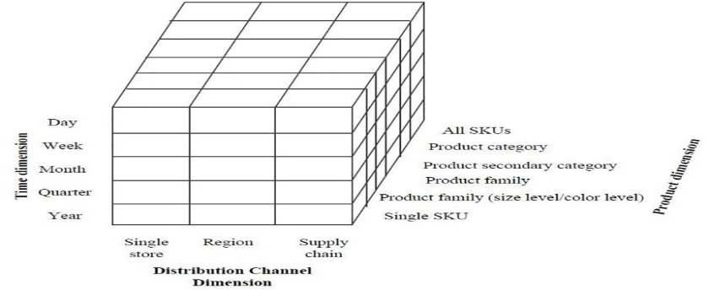

Figure 6: Data aggregation structure

For a given stage in a supply chain (e.g., retailing, wholesaling, or manufacturing), demand for  
products is realized at the individual order line level at a specific time. To facilitate decision  
making in an organization, this information is subsequently aggregated along important  
dimensions such as product, location, customer, and time. The basic input for forecasting is  
constructed from this selected level of data aggregation. Therefore, understanding the hierarchy  
and characteristics of data forming may reveal useful information to enhance forecasting  
outcome (Syntetos et al., 2016)

Extant literature has considered two types of data aggregation: temporal and cross-sectional.  
Temporal aggregation refers to a process in which demand recorded in higher-frequency time  
buckets (e.g., hourly, daily) is combined in lower-frequency time buckets (e.g., weekly,  
monthly). Meanwhile, cross-sectional aggregation is a process that combines multiple time series  
based on the product family, location, or customer. A review of different forms of data  
aggregation is provided below

2.3.1 Temporal Aggregation  
Temporal aggregation has often been considered an effective way to eliminate zero-demand periods and thus improving forecasting for intermittent demand

There are two forms of temporal aggregation: non-overlapping and overlapping. The former  
divides the time horizon into consecutive non-overlapping buckets of equal length while in the  
latter equal-length buckets are constructed by dropping the oldest observation and adding the  
newest. The concern with non-overlapping aggregation is the reduced number of data points used  
for forecasting (a potential loss of information), especially for short demand histories. That said,  
the result from Nikolopoulos et al. (2011) has empirically confirmed the benefits of such an  
approach for intermittent demand series

Using a sample of monthly demand of 5,000 SKUs over 7 years of history, Nikolopoulos et al.  
(2011) proposed the aggregate-disaggregate intermittent demand (ADIDA) approach which  
consists of the following steps: (1) aggregate monthly demand into lower-frequency series (e.g.,  
quarterly data); (2) apply forecasting methods (e.g., Naïve, SBA) on the new data and obtain the  
one-step ahead forecast; and (3) disaggregate the forecast into monthly forecasts using a chosen  
set of weights (e.g., equal weights). Interestingly, this approach may lead to improvements for a  
given forecasting method; thus, ADIDA may be perceived as a method self-improvement  
mechanism. A discussion of the mathematical properties of ADIDA can also be found in  
Spithourakis, Petropoulos, Nikolopoulos, and Assimakopoulos (2014). More relevant to our  
study is that Nikolopoulos et al. (2011) illustrated a promising outcome from considering an  
aggregation level equal to the lead-time plus one review period. This result has an important  
implication for inventory control purposes, particularly with the order-up-to policy. In fact, later  
work has confirmed that this aggregation level resulted in higher realized service levels and a  
higher inventory efficiency with respect to service-cost performance (Babai et al., 2012)

Subsequent studies have refined and/or expanded the ADIDA approach to improve forecast  
accuracy. Kourentzes, Petropoulos, and Trapero (2014) proposed the multi aggregation  
prediction algorithm (MAPA) that constructed multiple time series through temporal aggregation  
with different time bucket sizes and then leveraged the benefit of forecast combination on this  
group of time series. Petropoulos and Kourentzes (2015) further examined both method and  
temporal combinations; the former combined different forecasting methods on the same time  
series (e.g., Naïve, Croston’s, SBA, and SES) while the latter combined different time series  
generated via different aggregated frequencies. Petropoulos, Kourentzes, and Nikolopoulos  
(2016) modified ADIDA via inverting the intermittent demand series. Last but not least, Lei et  
al. (2016) combined MAPA and the fuzzy Markov chain model and found this improved  
approach to be more stable and robust under various conditions.

2.3.2 Cross-sectional Aggregation

In contrast to temporal aggregation, cross-sectional aggregation usually leads to a reduction in data variation (Babai et al., 2012). Here data is aggregated based on a specific hierarchical structure of the product, the location, or the customer

**In summary**, drawing on the literature of intermittent demand, this study examines various forecasting methods (e.g., SES, Croston, SBA) in the context of combined temporal and cross-sectional data aggregation with an emphasis on lead-time (plus one review period) and customer heterogeneity.

**3.METHODOLOGY**

The methodology steps are presented in figure 4. The detailed steps are described as follows:

Figure 7: Methodology steps [5]

Throughout this process, both quantitative and qualitative analyses were performed. The  
qualitative analysis included site visits and interviews with company employees to understand  
market structure, forces influencing demand patterns, and current practices of demand  
forecasting and inventory control; this allowed us to identify quantitative data to be collected and  
validate/justify analysis outcome. The process is described in the following sub-sections with a  
focus on the quantitative analysis.[5]

**3.1 Data Collection**The collection of data was directed through a series of meetings with the sponsor company. These meetings allowed us to form a historical picture of how inventory management activities had been performed and identify relevant data for the project from existing information systems. Data collected for this study should include demand time series, lead-time, unit cost, and customer information.

**3.2 Data Preparation**The collected data was aggregated and/or re-formatted for further analysis. Various approaches were applied to identify and handle missing data and outliers. Next, demand was aggregated into weekly and monthly time buckets. Finally, these demand time series were split into two parts: the training set and the test set.

**3.3 Data Analysis**The purpose of this step is to understand the main characteristics of the data prepared in the previous step. Descriptive statistics of demand, lead-time, and unit cost were calculated. We also categorized demand patterns based on the SBC classification framework

**3.4 Demand Forecasting**Having examined the characteristics of our dataset, we are ready to apply various forecasting methods. This section describes the three time-series forecasting methods used for different levels of data aggregation in our study [6]

**Table 3**. Literature review: Demand Forecasting Model Selection

|  |  |
| --- | --- |
| **Reference** | **Abstract** |
| [1]- sMDL-NN | An appropriate model selection criterion is introduced to determine the optimal model. In order to tackle the problem of **erratic demand**, dropping outliers, seasonal adjustment techniques and aggregation technique are introduced. In addition, a new forecasting accuracy estimator is proposed to improve the generalization capability of zero-demand data. Six other benchmark methods are also applied, namely Syntetos and Boylan’s method, GM, SVM, MS, ELM and NN. Our experimental results show that the performance of our proposed method outperforms others. Our findings suggest that due to the complexity of sales data, managers should consider model selection, and **sMDL-NN is** an ideal candidate model to achieve this goal. The numerical investigation is conducted at the supply chain level. Experimental results and encompassing tests indicate that our proposed sMDL-NN model is superior. The forecasting results of the proposed RMAPE are consistent with MAE |
| [9] | Performance results are evaluated for all methods and for all demand types. Based on the performance results, order of methods according to their success results is obtained |
| [12] | The result of the analysis shows that traditional forecast accuracy measure is inadequate for selecting best forecast model. Nevertheless, our result shows that no forecast method (Simple Exponential Smoothening (SES), **Croston and Modified Croston (SBA)** explicitly showed superior performance in all the traditional measures utilized.[12] |
| [13] | The intermittent demand patterns for medical supplies are generally classified as lumpy, erratic, smooth, and slow-moving demand. This study was conducted with the purpose of advancing a tertiary pediatric intensive care unit’s efforts to achieve a high level of accuracy in its forecasting of the demand for medical supplies. On this point, several demand forecasting methods were compared in terms of the forecast accuracy of each. The results confirm that applying Croston’s method combined with a single exponential smoothing method yields the most accurate results for forecasting lumpy, erratic, and slow-moving demand, whereas the Simple Moving Average (**SMA) method is the most suitable for forecasting smooth demand**. In addition, when the classification of demand consumption patterns were combined with the demand forecasting models, the forecasting errors were minimized, indicating that this classification framework can play a role in improving patient safety and reducing inventory management costs in health care institution |
| [14] | Abstract Demand forecast accuracy in the service supply chains e.g., spare parts is critical for customer satisfaction and its financial performance. This is a typical logistic network which is affected by irregular demand resulting from contract and non-contract business strategies. Hence, existing forecasting methods that work excellent with smooth and linear demand patterns become less accurate with increasing erratic, lumpy and intermittent demands. Moreover, increasing number of stock keeping units (SKUs) in service supply chains have computational limitations. This is because of the fact that demand keep on fluctuating their demand classes that result in uncertainty and consequently, leads to higher target stock levels (TSL) and lower reorder point (ROP) to ensure higher customer satisfaction. This raises interest in using AI for service supply chains to improve demand forecast accuracy. In this paper, we present a survey of existing forecasting methods used in service and non-service supply chains to select best performing AI methods and performance measures, using ABC classification. **Neural network (NN) and Mean Square Error (MSE), are subsequently modelled and used** in aircraft spare parts supply chain using data collected from Dassault Aviation, as a function of most commonly used aggregated demand features. **The results are compared with frequently and best performing forecast methods for intermittent demand as Croston, Croston SBJ and Croston TSB; and classical methods as moving average (MA) and single exponential smoothening (SES). T**he analysis and results suggest that NN with higher number of features improve demand forecast accuracy significantly for intermittent demands along with reduction in associated financial implications |
| [16] | In empirically investigating the forecasting methods on the performance block (the final 22 months  of the 66-month actual distribution) using three traditional statistical measures of forecast accuracy, we found none of the methods under consideration to be consistently superior to the others. However, when the methods are tested over considerably more time periods (100 replications of 100 months using our two-stage approach), **SBA** is found to be the best performing method overall in terms of statistical accuracy. |

**The traditional forecasting methods**

The traditional forecasting methods have focused on regular demand patterns; however, Croston (1972) was the first who presented an exponential smoothing method for the irregular demand forecast inventory control system. He concluded that intermittent demand could lead to improper stock levels and suggested to use separate estimates of demand size and interval consecutive demand occurrences. Syntetos (2001) reassessed Croston’s method with focus on its forecast performance and presented modification with approximately unbiased demand/period estimates and showed superiority of the revised method. Syntetos, Babai, and Gardner (2015) investigated that simple parametric or bootstrapping method is more appropriate to forecast demand mean and variance for intermittent demand class. The results confirmed the suitable performance of the former and questioned the benefit of latter relative to its complexity. These extensions are referred as **Croston SNB, Croston TSB and Croston SBJ methods** (Kourentzes, 2014).[14]

**Summary:** **The superiority of the AI based NN methods**. [14]

Amin-Naseri and Tabar (2008) have employed recurrent NN, multi-layered perceptron NN and generalized regression NN for forecasting spare parts from lumpy demand class. Rreal data are gathered to examine the forecasting performance of proposed approaches by comparing it to Croston’s and Syntetos and Boylan approximation methods. The results confirmed the superiority of the AI based NN methods. [14]

In brief, model selection is very important to forecast the demand for short life cycle products because of the considerable irregularity in their sales data. After reviewing all the papers we selected, we propose a new forecasting accuracy measure for the model to deal with zero demand, and introduce a dynamic neural network, minimum description length neural network (MDL-NN), as the core part of the forecasting model. MDL was originally used for data compression, which is a technique from algorithmic information theory, which indicates that the best hypothesis for a given data set is the assumption that results in maximum data compression. One seeks to minimize the sum of length, which includes an effective description of the model and length, and an effective description of the data when coding with the model. In time series forecasting, the description length of a model is the sum of the model description length and the model prediction error. MDL-NN searches for the optimal model size (i.e. the number of neurons in neural network), and avoids overfitting or underfitting by minimizing the model’s description length and its performance.[1]

**4. FORCASTING ACCURACY MEASUREMENTS**

**Table 4.** Literature review: Demand Forecasting Accuracy Metrics

|  |  |  |
| --- | --- | --- |
| Reference | Abstract | Accuracy Metrics |
| [14] | In this paper, we present a survey of existing forecasting methods used in service and non-service supply chains to select best performing AI methods and performance measures, using ABC classification. **Neural network (NN**) and **Mean Square Error (MSE),** are subsequently modelled and used in supply chain using data collected from Dassault Aviation, | MSE |
| [1] | The RSMAPE method imposes a larger penalty on the underestimated values on the overestimated values. This property is extremely appropriate for the sales forecasting. Although underestimation does not increase inventory cost, it results in not only losing current sales and revenue reduction, but also decreasing the level of customer satisfaction. Demand overestimation only increases the inventory cost. The MAE does not have this property. However, in our background, the value of samples is small, thus, big MAPE value doesn’t always indicate that the model is ineffective, **MAE is more appropriate than other two measurements to judge the effectiveness of model.** | MAE |
| [6] | Among various measures**,** MASE has been highly recommended for intermittent demand because it is scale-free and less sensitive to the existence of trend and/or seasonality (Hyndman, 2006); RGRMSE has also been shown to be a robust measure in the presence of outliers (Syntetos & Boylan, 2005). Another important measure for our study is the RMSE. Despite its scale-dependency it is a useful measure to estimate demand variation (or standard deviation) for inventory control purposes. **In this study, smoothed mean square error (MSE) has been used to estimate the variance of our forecast.** | MSE |
| [4] | Example scale-dependent metrics include the Mean Squared Error (MSE), the Mean Absolute Error (MAE), the Mean Absolute Percentage Error (MAPE) which is simply defined as the mean The key metric in this category is Mean Absolute Scaled Error (MASE) | MAE  MAPE  GMRAE  MASE |
| [8] | That is, the first observations are used as an optimization sample to select the smoothing parameter over the range 0.05 to 0.30 (in steps of 0.01) that minimizes the mean squared error **(MSE)** per series. | MSE |

**In summary:** After review, we present a survey of existing forecasting methods used in service and non-service supply chains to select best performing AI methods and performance measures, using ABC classification. **Neural network (NN**) and **Mean Square Error (MSE),** are subsequently modelled and used in supply chain using.[14]

**5. LITERATURE REVIEW – EXPERIMENT RESULT [1] & [14]**

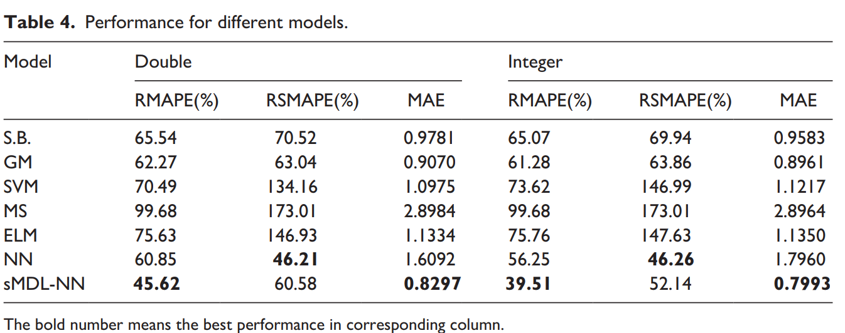

**Result:** Six other benchmark methods are evaluated: Syntetos and Boylan’s method, GM, SVM, MS, ELM and NN. Our experimental results show that the performance of MDL-NN method outperforms others [1]

**6. CONCLUSION & FURTHER RESERACH**

**Conclusion:** For the intermittent demand forecasting problem of medical consumables with a short life cycle, the finding of my literature review is a dynamic neural network model based on optimized model selection procedure to select optimal structure of neural network. One critical have to address is to avoid underfitting and overfitting, especially in our limited historical data, which is essentially the problem of model selection.

In order to tackle the problem of erratic demand, dropping outliers, seasonal adjustment techniques and aggregation technique are introduced. In addition, a new forecasting accuracy estimator is proposed to improve the generalization capability of zero-demand data. Experimental results show that the performance of MDL-NN outperforms others.

**Further research**: Intermittent demand management is a very complicated issue. Further research can be to integrate the forecasted results into inventory, logistics distribution, and pricing operations, such as markdown decisions, to develop models and algorithms to solve practical problems.

**Reference**

[1] Liu, Peipei. "Intermittent demand forecasting for medical consumables with short life cycle using a dynamic neural network during the COVID-19 epidemic." *Health informatics journal* (2020): 1460458220954730.

[2] Burgess, K. et al. “Supply chain management: a structured literature review and implications for future research.” International Journal of Operations & Production Management 26 (2006): 703-729.

[3] Takeyasu, Daisuke et al. “Improving Forecasting Accuracy in the Case of Intermittent Demand Forecasting.” International Journal of Advanced Computer Science and Applications 5 (2014): n. pag.

[4] Waller, D.. “Methods for Intermittent Demand Forecasting.” (2015).

[5] Argyrios Syntetos “Forcasting of intermittent demand” ( 2001)

[6] Ngan Ngoc Chau “Intermittent Demand Forecasting for Inventory Control: The Impact of Temporal

and Cross-sectional Aggregation” (2020)

[7]Kourentzes, N.. “On intermittent demand model optimisation and selection.” International Journal of Production Economics 156 (2014): 180-190.

[8] Syntetos, A. et al. “Forecasting intermittent inventory demands: simple parametric methods vs. bootstrapping ☆.” Journal of Business Research 68 (2015): 1746-1752.

[9] Kaya, Gamze Ogcu et al. “Intermittent demand forecasting: a guideline for method selection.” Sādhanā 45 (2020): 1-7.

[10] Lolli, F. et al. “Machine learning for multi-criteria inventory classification applied to intermittent demand.” Production Planning & Control 30 (2019): 76 - 89.

[11] Syntetos A A and Boylan J E 2005 The accuracy of  
intermittent demand estimates. International Journal of  
Forecasting 21: 303–314

[[12]Oguji, Nnamdi. “Forecasting for intermittent spare parts in single-echelon multi-location and multi-item logistics network: Case KONE Global Spares Supply.” (2013)

[13] Cheng, Chen-Yang et al. “Intermittent Demand Forecasting in a Tertiary Pediatric Intensive Care Unit.” Journal of Medical Systems 40 (2016): 1-12.

[14] Amirkolaii, K. N. et al. “Demand Forecasting for Irregular Demands in Business Aircraft Spare Parts Supply Chains by using Artificial Intelligence (AI).” IFAC-PapersOnLine 50 (2017): 15221-15226.

[15]Martin, D. et al. “A New Metric for Lumpy and Intermittent Demand Forecasts: Stock-keeping-oriented Prediction Error Costs.” ArXiv abs/2004.10537 (2020): n. pag.

[16] Nicoletti, L. et al. “Intermittent demand forecasting and stock control: An empirical study.” (2013).

[17] Molina, A. and J. Parreño. “Forecasting erratic demand of medicines in a public hospital : A comparison of artificial neural networks and ARIMA models.” (2016).

# [18] Zeynep Hilal Kilimci, A. Okay Akyuz, Mitat Uysal, Selim Akyokus, M. Ozan Uysal, Berna Atak Bulbul, Mehmet Ali Ekmis, "An Improved Demand Forecasting Model Using Deep Learning Approach and Proposed Decision Integration Strategy for Supply Chain", *Complexity*, vol. 2019, Article

[19] “A Machine-learning-based System for prediction service level Failures in Supply Chains”

[20] Luis Aburto, Richard Weber, ”Improved supply chain management based on hybrid demand forecasts”, Applied Soft Computing, Volume 7, Issue 1, 2007, Pages 136-144, ISSN 1568-4946,

[21] He Y, Liu N. Methodology of emergency medical logistics for public health emergencies. Transp Res E Logist Transp Rev. 2015 Jul;79:178-200. doi: 10.1016/j.tre.2015.04.007. Epub 2015 May 17. PMID: 32288598; PMCID: PMC7147567.

[22] GabRIELLE Gauthier Melancon , A Machine Learning Based System for Predicting Service Level Failures in Supply Chains

[23] Tugay, R. and S. Ögüdücü. “Demand Prediction using Machine Learning Methods and Stacked Generalization.” DATA (2017).

[24]Aburto L., Weber R. (2007) A Sequential Hybrid Forecasting System for Demand Prediction. In: Perner P. (eds) Machine Learning and Data Mining in Pattern Recognition. MLDM 2007. Lecture Notes in Computer Science, vol 4571. Springer, Berlin, Heidelberg. <https://doi.org/10.1007/978-3-540-73499-4_39>

[25] Abolghasemi, M. et al. “Demand forecasting in supply chain: The impact of demand volatility in the presence of promotion.” Comput. Ind. Eng. 142 (2020): 106380.

[26] López, C. and A. Ishizaka. “A hybrid FCM-AHP approach to predict impacts of offshore outsourcing location decisions on supply chain resilience.” Journal of Business Research 103 (2017): 495-507.

[27] Islam, Samiul and S. Amin. “Prediction of probable backorder scenarios in the supply chain using Distributed Random Forest and Gradient Boosting Machine learning techniques.” Journal of Big Data 7 (2020): 1-22.

[27] Syahrir, I. et al. “Healthcare and Disaster Supply Chain: Literature Review and Future Research.” Procedia Manufacturing 4 (2015): 2-9.

[28] Brintrup, A. et al. “Supply chain data analytics for predicting supplier disruptions: a case study in complex asset manufacturing.” International Journal of Production Research 58 (2020): 3330 - 3341.

[29] Baryannis, George et al. “Supply chain risk management and artificial intelligence: state of the art and future research directions.” International Journal of Production Research 57 (2019): 2179 - 2202.